**School 21 3rd Grade Supply List**

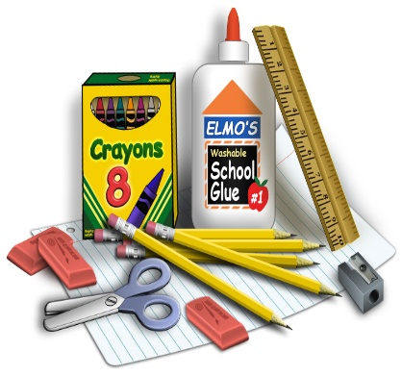

[This Photo](http://pixel-slinger.deviantart.com/art/Elementary-School-Supplies-358344655) by Unknown Author is licensed under [CC BY-NC-ND](https://creativecommons.org/licenses/by-nc-nd/3.0/)

(Look for early sales!)

* Two boxes of #2 pencils (replace throughout the year)

* Pencil sharpener with cap (replace throughout the year)

* 6 Marble notebooks (no spiral, can be different colors)

* 6 Folders (2 must be strong plastic)

* 2 Highlighters

* Pack of dry erase markers and eraser

*Multiplication cards (Dollar stores)

*Small box of crayons or colored pencils

*Box of washable colored markers

*1 Elmer’s glue

*Pack of glue sticks

*3x5 index cards

*2 scotch tapes

*1 Pack *wide ruled loose-leaf paper* and 1 pack *graph paper*

*Cursive writing “workbook” (Target, Walmart, bookstores, or online)

HOUSEKEEPING SUPPLIES: **3** boxes of tissues, **3** Lysol wipes, baby wipes,

**2** bottles hand sanitizer, and paper towels.

**\*One big clear box with lid (shoebox size) for storing on class shelf**. This is to keep children’s supplies separate from their classmates. There will be no sharing.

THANK YOU!

PLEASE PUT YOUR CHILD’S NAME ON EVERYTHING

Mrs. Carone (3-31) and Mrs. Maurno (3-30)